SMPD3 methylation and expression as tumor stratification biomarkers and clinical outcome prognosticators for clear cell renal cell carcinoma(CCRCC)

Abstract

Methods
Patient samples
During routine clinical assessment of 85 patients with newly diagnosed clear cell renal cell carcinoma treated with surgery at the Fudan University Shanghai cancer center . Tissue of cancer and matched adjacent macroscopically normal renal tissue were shored at -80℃ in the Tissue Bank。All patients have signed consensus before surgery。（table 1 clinicopathological features）DNA and RNA was extracted as protocol by DNA/RNA IsolationKit(Tiangen)
Cell culture and Cell lines 5-Aza-20-deoxycytidine treatment
RCC cell lines 786-O was routinely maintained in DMEM (Invitrogen, San Diego, CA,USA) supplemented with 10% FCS at 37 1C in 5% CO2. The demethylating agent 5-Aza-20-deoxycytidine (Sigma-Aldrich,Dorset, UK) was freshly prepared in dd H2O and filter sterilised. Cell line was plated in 75-cm2 flasks in DMEM medium supplemented with 10% FCS at differing densities,depending on their doubling time, to ensure that both control and 5-Aza-20-deoxycytidine-treated lines reachedB75%confluency at the point of RNA extraction. After 24 h, cells were treated with 5 mM 5-Aza-20-deoxycytidine. The medium was changed 24 h after treatment and then changed again after 72 h. RNA was prepared 5 days after treatment using RNABee (AMS Biotechnology, Oxford, UK). Total RNA from the cell line 5-Aza-20-deoxycytidine was isolated.
Bisulfite modification and methylation analysis.and Bisulfite
Sequencing:For bisulfite conversion, we used the EZ DNA Methylation-GoldTM Kit from Zymo Research For optimized bisulfite conversion, we employed 500 ng of genomic DNA and followed the manufacturer’s protocol DNA was denatured by the addition of Zymo M-Dilution buffer (contains NaOH) and incubated for 98℃ 10 min；64℃ 2.5 h in a thermocycler The methylation-specific primers were designed based on the sequencing data of the PCR-amplified bisulfite-modified cell line genomo using MethPrimer software. DNA.primer(Table 2 all primers including bsp、pyroseqencing、real time). The PCR amplified fragments were cloned into pMD19-T (Takara) 2h followed by transformation into DH5a.8 clones were selected to PCR validation. Transformants containing recombinant plasmids were selected by blue/white colony screening.
Pyroseqencing
To demonstrate the relative degree of methylation, DNA isolated from RCC and matched normal tissues were analysed using pyrosequencing (PYRO-SEQ). Measurements were performed according to the manufacturers' protocol using the PyroMark Q24 pyrosequencing system (Qiagen). Pyrosequencing (PyroMark Gold Q96 Reagents; Qiagen) was then performed using the PyroMark Q24 system (Qiagen) according to the manufacturer’s protocol. The sequencing assay was validated using an internal control (a non-CpG cytosine within the target methylation sequence region).
Quantitative real-time PCR
RT–PCR conditions
PCR cycling conditions consisted of 5 min at 95 1C, followed by 30 cycles of 45 s of denaturation at 95 1C, 45 s of annealing at 55–60 1C and 45 s of extension at 72 1C. Semiquantitative analysis of expression was carried out using LabWorks software (Ultraviolet products, Upland, CA, USA). (daixu)
Real time PCR
The qRT-PCR analysis was performed using the TaqMan PCR method with a 7900HT Fast Real-Time PCR System (Applied Biosystems) with cDNA from Th0s separated from the other patients with MCNS at relapse and subsequent remission.. The two genes previously analyzed using were assayed. Each gene was assayed three times for each sample. Aliquots of cDNA equivalent to 300 ng of total RNA were used in the RT-PCR reactions. GAPDH (Hs99999905_m1) was used as an endogenous control for normalizing the RNA concentrations. Differences in the CT values between the tested genes and endogenous control (ΔCT) were calculated and used for subsequent statistical analyses.
Statistical analysis
Paired t test was used to value difference between cancer and matched normal tissue. Univatiable ANOVA analysis and multiple linear correlation to value the association of methylation status with sex 、age、furhman grade、disease stage、metatsis .ROC was preformed to choose a optimal threshold value.Kaplain-Meir analysis was used to do survival analysis and Log-rank to test. Using SPSS 19. For all tests, P < 0.05 was used as the level of significance.

Result

Analyze location of array data
We search methylation array data in Pubmed, and located array data on genes. GGT6：locates between the first exon and the second exon、FBXW10：locates in the first exon，and belong to CpG island、LEP：locates in promoter region and belong to CpG island、HIST1H3E：locates in promoter region and belong to CpG island、SMPD3：locates between the first exon and the second exon，and belong to CpG island、CD9：locates in promoter region and belong to CpG island
Validation of Methylation array data in RCC cell line 786-O
We first validate predict regions in a RCC cell line 786-O，primers were designed including predict regions. And found difference in FBXW10 （84.4% VS 22.2%）and SMPD3（ 82.9% VS 35.7%） (Table 2（所有的引物） and Figue2
Validation of FBXW10 and SMPD3 in 85 paired RCC tissues
We design primers according to the result of BSP, and test the sequence which shows the most different in BSP. In pyrosequencing product, FBXW10 it conclude 4 CpG sites, we named them fCpG1、fCpG2、fCpG3、fCpG4, and SMPD3 conclude 7 CpG sites, we named them sCpG1、sCpG2、sCpG3、sCpG4、sCpG5、sCpG6、sCpG7. Methylation rate of FBXW10 defines as average methylation status of fCpG1、fCpG2、fCpG3、fCpG4 as well as SMPD3.SMPD3 methylation rate in cancer is significant higher than matched normal tissue (48.78%VS 34.62%,p<0.001).（Figure 1） Univariated Analysis SMPD3 methylation rate and sex 、age、furhman grade、disease stage. There is no association between SMPD3 methylation rate and sex and age both in cancer and normal tissue . And there is significant higher methylation rate in normal tissue when furhman grade is lower, the methylation rate of SMPD3 in normal tissue of furhman grade I、II、III、IV is separate 46.88% 、36.85% 、32.98% 、25.71%（p=0.004 ）（Figure3）.But there is no difference in RCC according to furhman grade. Tumor size ranges from 1.5cm to 14cm with mean size 6cm, and the larger the tumor is the less methylated in both RCC and normal tissue, especially in normal tissue with p value less than 0.001.（Figure 4）We valued disease status as organ confined (TNM stage T1-2N0M0)、locally advanced (TNM stage T3-4N0-1M0) and metastasis disease(T0-4N0-1M1), significant difference are both in RCC and normal tissue with p value 0.032 and 0.003, to analysis further we could see that methylation rate has no difference between locally advanced disease and metastasis disease both in RCC and normal tissue. In normal tissue methylation rate of organ confined disease is higher than both locally advanced disease and metastasis, but in RCC we could see the rate is only significant higher in organ confined disease than locally advanced disease.（Table 3 and Figure 5）.We further did survival analysis, 20 patients who were diagnosed metastatic disease when or after surgery, 11 patients died after a mean 12.6(3-32) months following up. ROC confirmed that 26.4% was the optimal threshold value to predict survival with sensitivity 88.9% and specificity 63.6%. Area under cure was 0.747.(Figure 9) So we defined hypermethylation group of SMPD3 as methylation rate more than 26.4% and hypomethylation group as methylation rate less than 29.4%. Kaplain-Meir analysis showed that hypermethylation group survived longer than hypomethyaltion group with a significant p vavle 0.049.(Figure 10) Mean survival time was 17 months VS 10 months.
FBXW10 methylation rate in cancer is also significant higher than matched normal tissue (58.98%VS 38.66%,p<0.001).（Figure 6） Univariated Analysis FBXW10 methylation rate and sex 、age、furhman grade、disease stage. There is no association between FBXW10 methylation rate with all above in cancer and normal tissue. Further analysis we found that only in T1 stage RCC cohort, methylation rate of RCC tissue was associated with furhman grade, the higher furhman grade was, the higher methylation rate was, with a significant p value 0.020(Figure 7 and 8). The methylation rate of FBXW10 in T1 stage RCC tissue of furhman grade I、II、III is separate 51.89%,60.37% and 66.18%.
Gene expression
The qRT-PCR analysis demonstrated that both SMPD3 and FBXW10 mRNA expression of was upregulated after 5-Aza-20-deoxycytidine treatment in cell line. SMPD3 raised 2.47 times and FBXW10 raised 1.67 times. (Figure 11)

Figure 1 Methylation rate of SMPD3（%）in RCC and Normal tissue
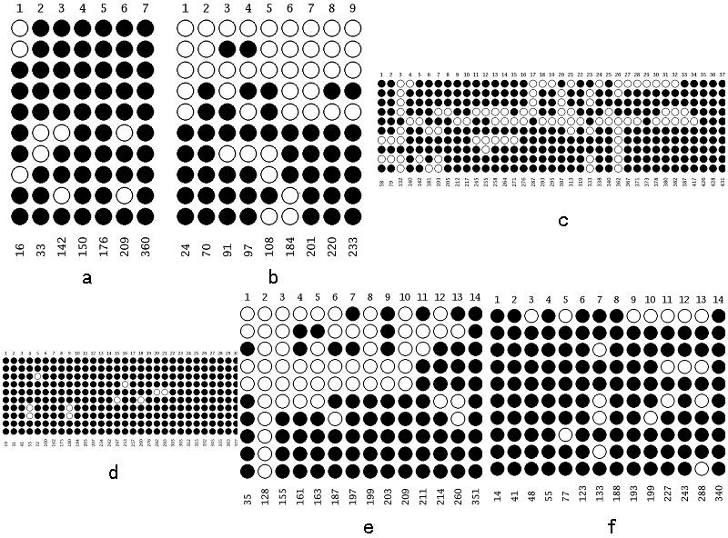 Figure 2 Results of BSP ：a GGT6、 b FBXW10、 c LEP d HIST1H3E、e SMPD3、 f CD9

Figure 3 Association of Methylation Rate of SMPD3 in matched normal tissue and Furhman grade

Figure 4 Association of Methylation Rate of SMPD3 and Tumor size

Figure 5 Association of Methylation Rate of SMPD3 and Tumor Stage

